From kindergarten through 5th grade, students spend about equal amounts of time learning about narrative and informational/argumentative texts. In 6th to 8th grade, students begin to focus more on informational/argumentative texts (55%) than narrative texts (45%). By the time students reach 12th grade, the majority of their literacy learning (70%) is spent understanding and producing informational/argumentative writing (Alterio, Carr, and Miller, June 2012).
Within these text types, there are five text structures all students must be able to identify and incorporate into their writing. The table identifies these 5 structures, tools for helping students understand each structure, and signal words.
 | Description | Sequence | Compare and Contrast | Cause and Effect | Problem and Solution
Key Questions | What are key examples and details? | What is the order? | How are things alike?  How are things different? | What is the cause? What is the effect? | What is the problem? How can it be solved?
Tools for student understanding | Idea Map:  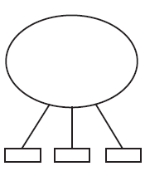 | Timeline:  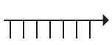  List: | Venn Diagram:  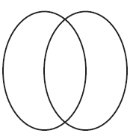 | T-Chart: 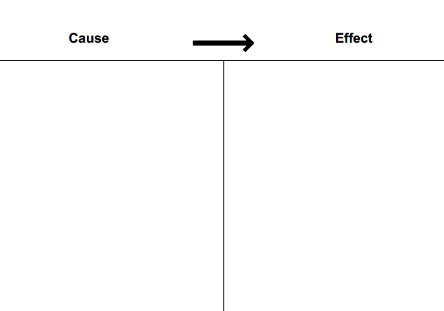 | Chain of Events:  Problem Event Event Event Solution
Examples of signal words  (Words that provide a signal to others of the text structure you are using) | Sight: brilliant, drab, large, opaque, small, translucent, transparent  Smell: aromatic, foul, fragrant, musky, odor, pungent, rancid, stinky  Taste: bitter, flavorful, sour, sweet, tangy, zesty  Touch: cold, damp, dry, gritty, hairy, hot, rough, smooth, sticky, wet  Sound: blare, din, loud, noisy, quiet, racket, rhythmic, tranquil | after, already, at last, at length, at that time, at this point, before, currently, during, earlier, eventually, finally, first, formerly, future, immediately, initially, lastly, later, meanwhile, next, now, past, present, prior, recently, subsequently, then, today, tomorrow, ultimately, until, when, while | Compare: alike, also, as, both, compare, each, equal, even, common, just as, like, neither, resemble, same, share, similar, too  Contrast: although, but, conversely, despite, different, neither/nor, however, instead, nevertheless, unlike, whereas, while, yet | Cause: because, being that, due to, that, for this reason, gives rise to, in that, in view of, leads to, owing to, seeing that, when, on account of  Effect: accordingly, all in all, as a result of, impact, outcome, consequently, for this reason, finally, hence, namely, since, therefore, thus | Problem: conundrum, dilemma, factor, issue, problem, puzzle, quandary, question, reason, situation  Solution: answer, possibility, proposition, solution, remedy, resolution

